**Project Report**

**1**   **INTRODUCTION**

**1.1** Overview

**A brief description about the project**

The project in the zoho books for Keerthi Sweets involves the creation of financial statement, which includes income statement, balance sheet and cash flow statement these statement are essential to assess the financial health of the company

**2**  **Problem Definition & Design Thinking**

**2.1** Empathy Map

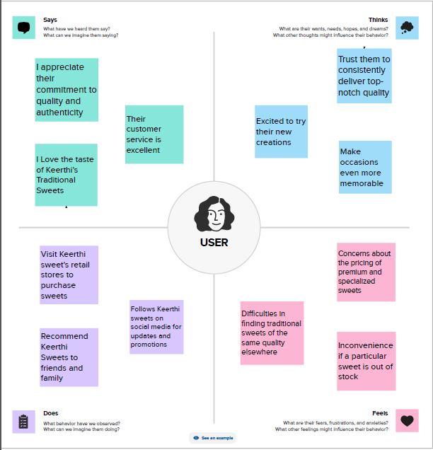

**2.2** Ideation & Brainstorming Map

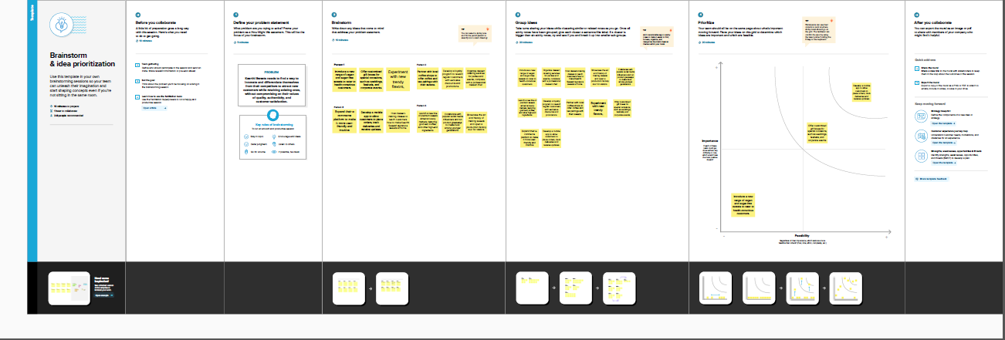

**3**  **RESULT**

Final findings (Output) of the project along with screenshots.

**PROFIT & LOSS**

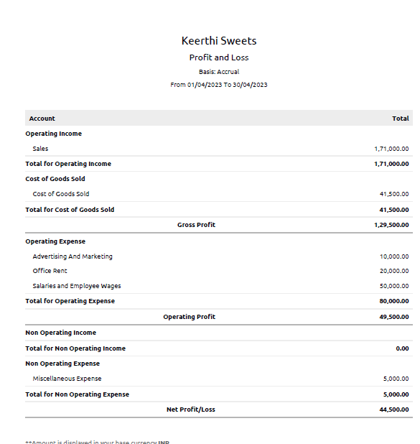

**BALANCE SHEET**

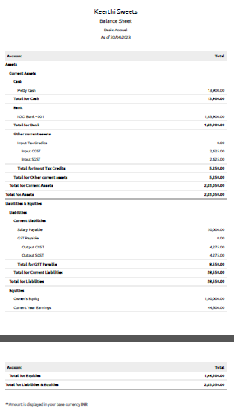

**4**  **ADVANTAGES & DISADVANTAGES**

List of advantages and disadvantages of the proposed solution

**4.1 ADVANTAGES**

* Invoicing
* Reminder emails
* Product creation

**4.2 DISADVANTAGES**

* Invoice customization
* Language selection with clients in different countries for one organization
* No Payroll services

**5**  **APPLICATIONS**

The areas where this solution can be applied

* Banking
* Inventory

**6**  **CONCLUSION**

All financial statements generated using Zoho Books will give an overview of

Keerthi Sweets financial health, which will help the management make informed

Decisions to improve the company's profitability and sustainability.

**7 FUTURE SCOPE**

* Improve in Mobile app
* To Manage their customer relationships through this app